**IBM CLOUD CLI**

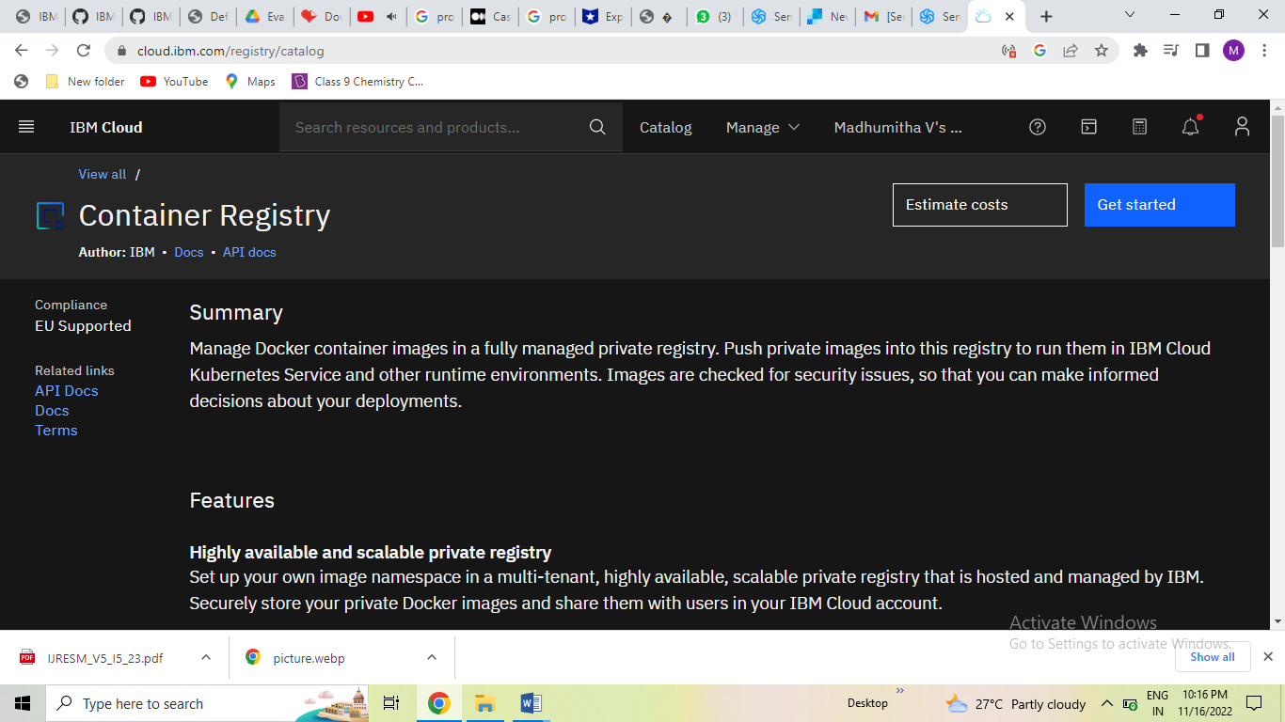

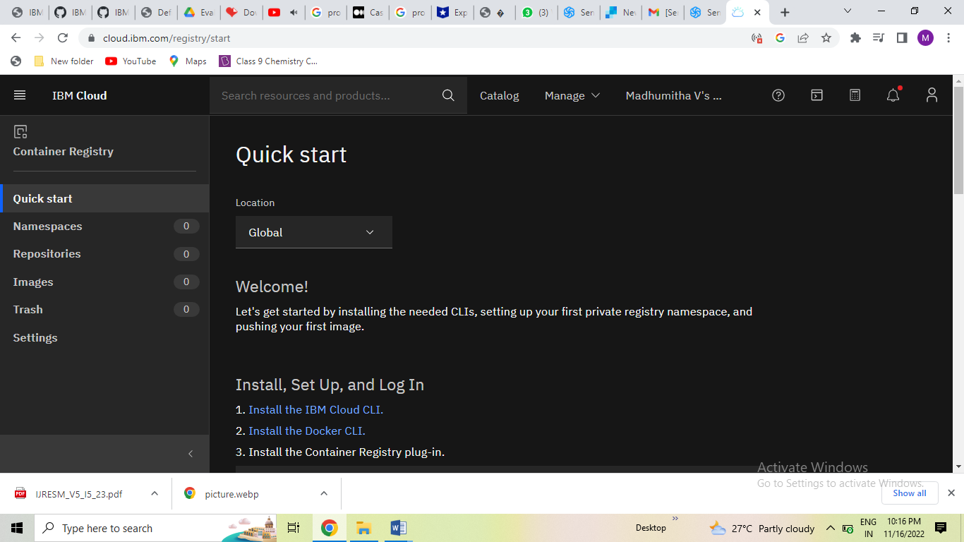

IBM CLOUD CLI is downloaded in the desktop.